

SIMATS ENGINEERING

Saveetha Institute of Medical and Technical Sciences
Chennai- 602105

Student Name: DEVADHARSHINI E Reg. No.: 192524483
Course Code: UBA5326 Slot: A
Course Name: PROBALISTIC METHODS AND LINEAR ALGEBRA IN ML
Course Faculty: Dr. Rameshwari, Dr.Gowri Senthil
Project title: Probabilistic Traffic Congestion Prediction using Poisson Distribution and Markov Chain Models
Module Photographs: (3 photographs –Module Photo, Individual student contribution module work in the project and presentation image)
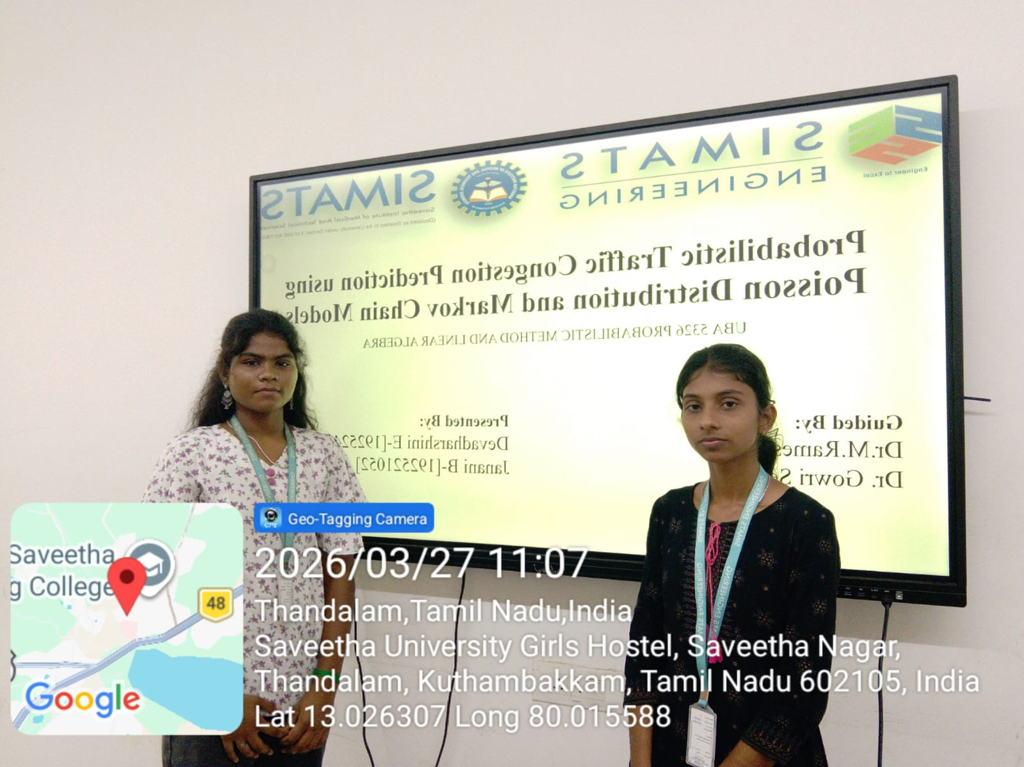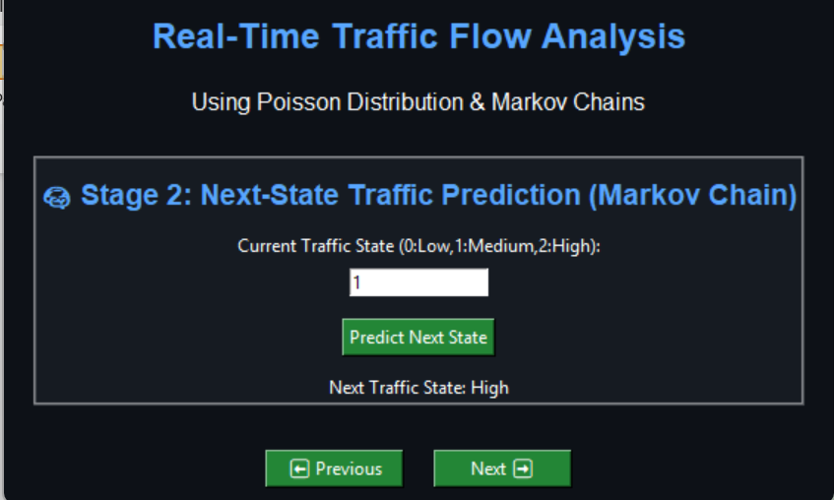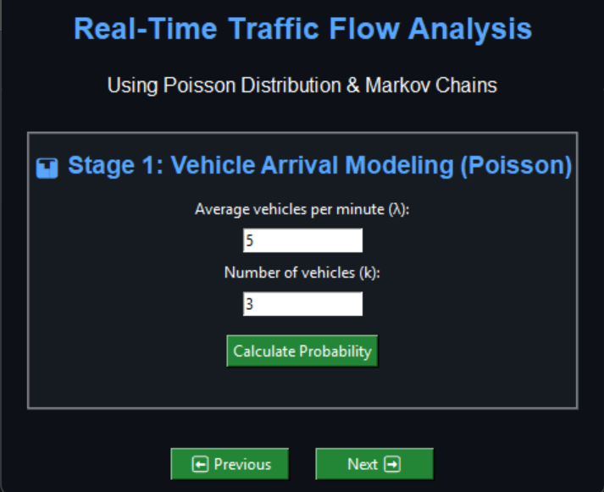
Project Description: (here you write what you did in this project (contribution) including Model Description
This project focuses on traffic flow analysis and prediction using statistical methods. Due to the rapid increase in vehicles, traffic congestion has become a major problem in urban areas. Traditional traffic systems use fixed timings and cannot handle real-time changes effectively. To overcome this, our project uses Poisson distribution to model the number of vehicles arriving per minute. This helps in understanding traffic intensity and analyzing how traffic varies over time. In addition, the project uses Markov Chain to predict future traffic conditions based on the current state. The traffic is classified into three states: Low, Medium, and High. Using a transition probability matrix, the system predicts the next traffic state. This approach helps improve traffic management, optimize signal timings, and reduce congestion. Overall, the system provides a simple and effective solution for real-time traffic prediction.

Student Signature Guide Signature

